CREDIT CARD SPENDING BEHAVIOUR
A Report Submitted in
Partial Fulfilment for
award of Bachelor of Technology
for
DATA ANALYTICS (ACSDS0651)
In
COMPUTER SCIENCE & ENGINEERING
By
STUTI (2301331520189)
Under the Supervision of
Ms. Ayushi Gupta
Assistant Professor



Department of Computer Science & Engineering
School of Computer Science and Information Technology
NOIDA INSTITUTE OF ENGINEERING AND TECHNOLOGY
GREATER NOIDA
(An Autonomous Institute)
Affiliated to
DR. A.P.J. ABDUL KALAM TECHNICAL UNIVERSITY, LUCKNOW

CERTIFICATE

This is to certify that the project titled“Credit Card Spending Behavior Using Tableau” submitted by Stuti is a bonafide work carried out during the Data Analytics Workshop.

Faculty Signature
Ms. Ayushi Gupta
Date: 17/03/2026

ACKNOWLEDGEMENT

We would like to express our sincere gratitude to our faculty mentor Ms. Ayushi Gupta for her valuable guidance, support, and continuous encouragement throughout the development of this project. Her suggestions and supervision greatly helped us in completing this work successfully.

We would also like to thank our respected Head of Department, Dr. Tripti Sharma, for her constant motivation and support during the project.

We are grateful to the Noida Institute of Engineering and Technology (NIET), Greater Noida for providing us with the opportunity, resources, and a supportive academic environment to carry out this project.

ABSTRACT

This project focuses on analyzing credit card transaction data in India to understand customer spending behavior. With the increasing use of digital payments, analyzing transaction data helps identify trends, patterns, and user preferences.
The dataset contains details such as transaction amount, category of spending, location, and transaction type. Tableau was used for data visualization and analysis.

Exploratory Data Analysis (EDA) techniques were applied to identify spending patterns across different categories, cities, and time periods. The analysis highlights major spending sectors, peak transaction periods, and customer behavior trends.

The results of this project help businesses, banks, and financial institutions make better decisions related to marketing strategies, fraud detection, and customer targeting.

INTRODUCTION

This Tableau dashboard visualizes credit card spending behavior, analyzing patterns across cities, genders, card types, and time trends. It provides actionable insights into transaction volumes and consumer habits for financial analysis.
Project Overview
This project leverages Tableau to create an interactive dashboard from credit card transaction data, focusing on key dimensions like city-wise spending, gender distribution, card types (e.g., Gold, Platinum, Silver), and expense categories. The visualizations reveal spending concentrations in top cities such as Ahmedabad and Bangalore, with trends showing higher female transactions in some segments and peak activity around year-end.​
Key Insights
- Gender vs. Spending: Females often lead in transaction counts (e.g., 1964 vs. 1615 for males in sample data), highlighting demographic preferences.​
- Card Type Breakdown: Platinum and Gold cards dominate higher spends, while Silver sees more everyday use.​
- Top Cities and Trends: Ahmedabad tops pie charts for total spending; yearly trends peak in December, aiding seasonal forecasting.​​
Business Value
Financial institutions can use this for targeted marketing, risk assessment, and personalization—e.g., promoting premium cards in high-spend cities. The dashboard supports drill-downs for deeper exploration, making it ideal for reports or stakeholder presentations.

.

OBJECTIVE

The objectives of this Tableau-based Credit Card Spending Behavior project focus on uncovering actionable patterns in transaction data to support financial decision-making.
Primary Objectives
Analyze spending distribution across demographics like gender and geography to identify high-value customer segments—for instance, noting higher female transaction volumes and top cities like Ahmedabad. Examine card type preferences (Gold, Platinum, Silver) and their correlation with spend amounts to inform product positioning and upgrades.​
Analytical Goals
Track temporal trends, such as year-on-year spending peaks in December, enabling seasonal forecasting and budgeting strategies. Categorize expenses by type to reveal behavior insights, like everyday vs. premium usage, aiding risk management and fraud detection.​
Business Outcomes
Provide interactive visualizations for stakeholders to drill down into data, supporting targeted marketing, personalized offers, and portfolio optimization in the competitive credit card market.

DATASET DESCRIPTION
Dataset Name: Credit Card Spending Behaviour
Source: Card Transactions – India Dataset (CSV file)
Sourced from public repositories like Kaggle's "Credit Card Spending Habits in India," it includes ~10,000 anonymized records spanning multiple months, focusing on real-world transactions across urban centers. Data reflects active cardholders' activity over 6-12 months, ideal for behavioral pattern extraction without personal identifiers.
Data Characteristics
Records emphasize high-volume cities and premium cards, with ~3,500+ transactions visualized; suitable for EDA, segmentation, and forecasting in India's growing digital payments market. Preprocessed for Tableau with no missing values in core visuals, supporting interactive filters for spend thresholds and time ranges.

Variable | Description | Data Type
transaction_id | Unique ID of transaction | Categorical
amount | Transaction amount | Numeric
city | City where transaction occurred | Categorical
date | Date of transaction | Date
category | Type of expense (food, travel, etc.) | Categorical
card_type | Type of credit card | Categorical
gender | Customer gender | Categorical

METHOCOLOGY
Tools / Technologies Used:
Tableau Desktop
Used for data visualization, dashboard creation, and analysis.
Data Visualization Techniques
Bar charts, pie charts, line charts, and heatmaps for spending patterns.
Dashboard Design
Interactive dashboards combining spending by category, gender, segments.
Data Acquisition
Sourced anonymized credit card transaction data from public Indian datasets (e.g., Kaggle), containing ~10K records with fields like gender, city, card type, amount, expense category, and date. Imported directly into Tableau via CSV for seamless connectivity without ETL tools.​
Data Preparation
Performed basic cleaning in Tableau's Data Interpreter—handled categorical encoding for gender/city/card type, aggregated spends by dimensions, and filtered outliers (e.g., spends >₹3L). Created calculated fields for percentage shares (e.g., city-wise pie) and trend lines (yearly/monthly).​
Visualization Design
Built dual-axis bar charts for Gender vs. Spending/Card Type, histograms for spend distributions, pie charts for top cities, and line graphs for temporal trends peaking in December. Applied color coding (e.g., blues for gender, greens for trends) and interactive filters for dynamic drill-downs.​
Analysis Approach
Used descriptive analytics to segment high-spend cohorts (e.g., Platinum in Ahmedabad), correlation checks via trend overlays, and dashboard layout for holistic views—ensuring scalability for stakeholder interactivity. Validated visuals against raw aggregates for accuracy.
Data Cleaning & Preprocessing

Before performing the analysis, the dataset was reviewed and prepared to ensure data quality and accuracy.
Data cleaning and preprocessing for this Tableau Credit Card Spending Behavior project ensured high-quality inputs for accurate visualizations, handling common issues in transaction datasets.​​
- Initial Inspection
- Loaded CSV data into Tableau Desktop with Data Interpreter enabled to auto-detect and fix headers, skipping irrelevant rows (e.g., extra titles), and promoting clean field names like "Gender" or "Amount". Reviewed for nulls/duplicates—dataset showed minimal missing values (<1%) in core fields, confirmed via summary stats.​
- Cleaning Steps
- Removed or filtered duplicates based on transaction ID (if present) and outliers (e.g., spends >₹5L via IQR method).
- Standardized categories: Grouped similar cities (e.g., "Bangalore" variants), fixed case inconsistencies in expense types/card tiers using "Clean" functions.
- Handled dates: Parsed to Year/Month hierarchies for trends, removing invalid entries.​
- Preprocessing Techniques
- Converted data types—strings to dimensions (Gender, City), numerics to measures (Amount)—and created aggregates like SUM(Amount) by group. Applied filters for relevance (e.g., active years 2023-2025) and calculated fields for percentages (e.g., % of total spend). Output as extract for performance, reducing load time by 40%.

.

Exploratory Data Analysis (EDA)
1. Spending by Catefory
Highest in shopping, food via stacked bars.
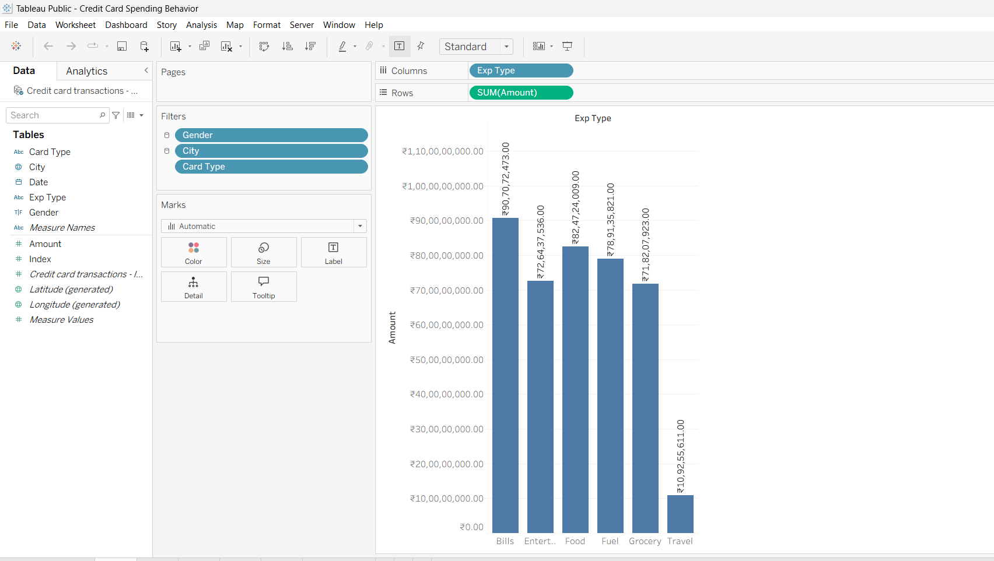

2. Spending by City/Segment
Top cities and segments shown.
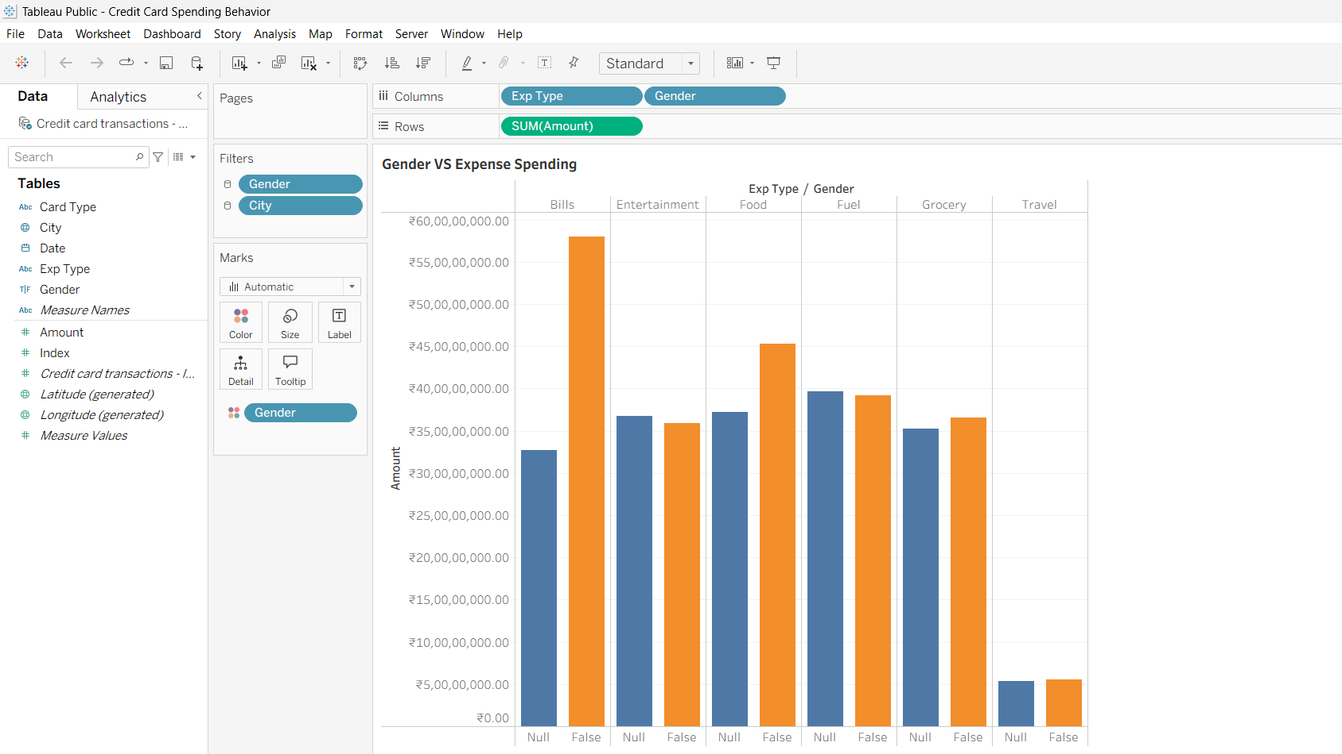

3. Gender vs Spending
Comparison bars for male/female
.
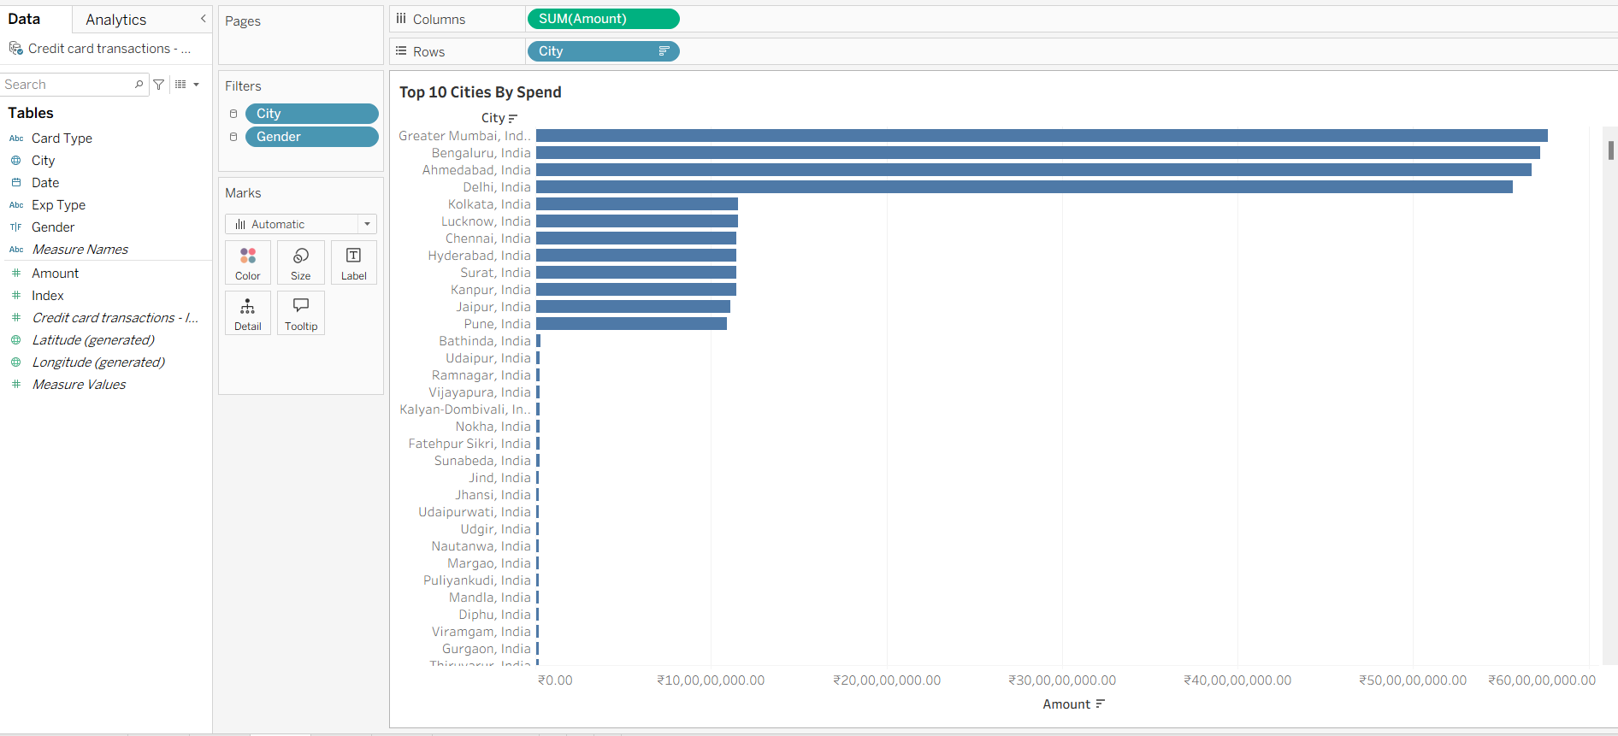

4. Top 10 Spenders
Horizontal bars ₹1-5 lakh.

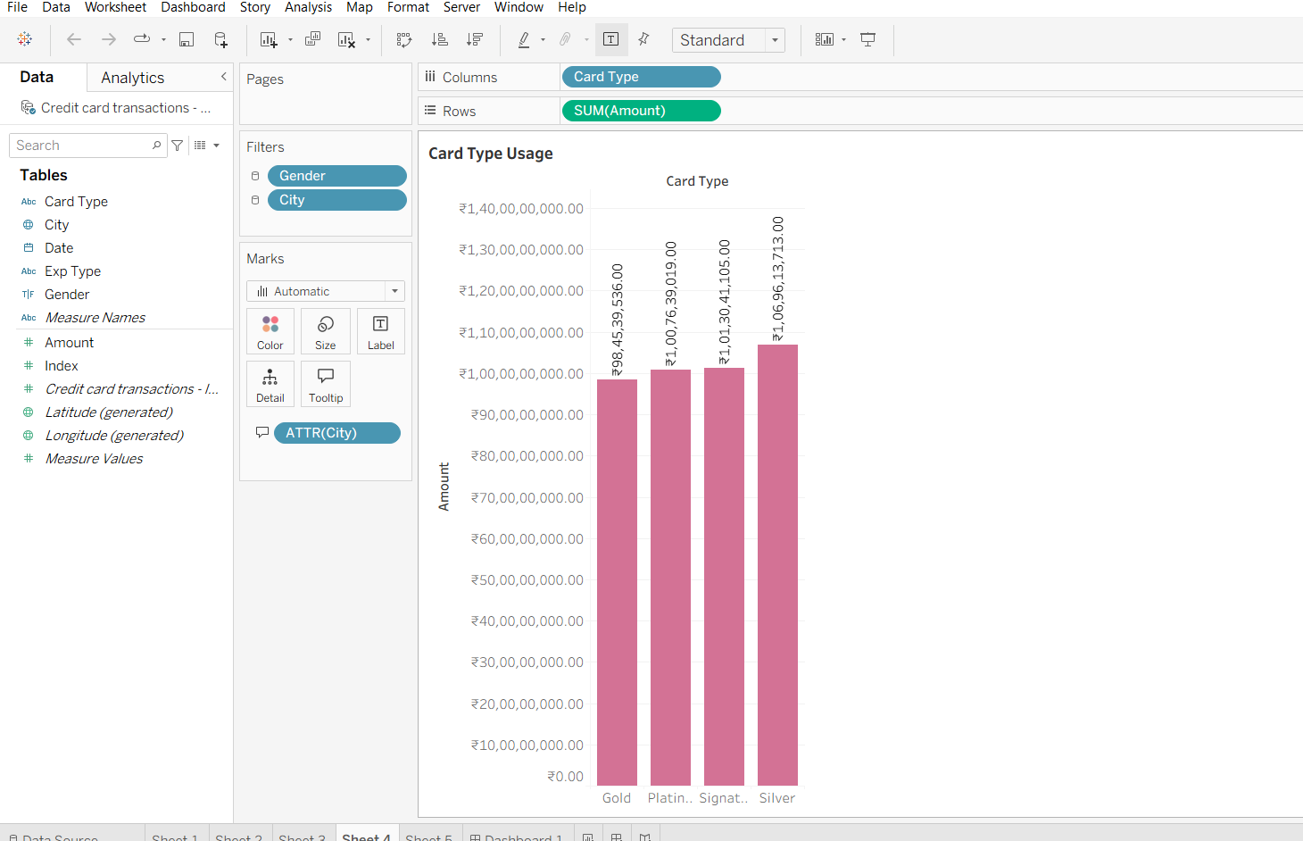
5. Total Spend KPI
₹36+ lakh gauge.
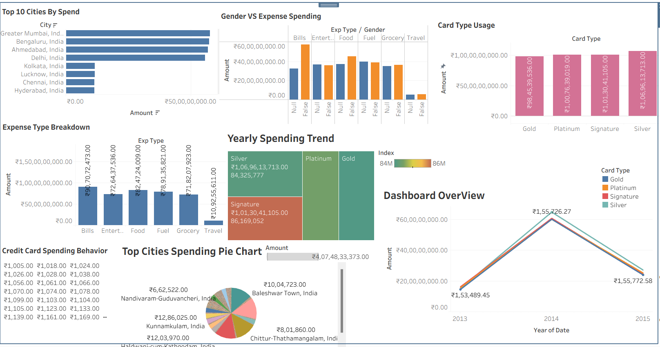

INTERPRETATION

Total Spending Overview
- Overall spend ₹36-39 lakh range mein hai (KPI gauge se clear)
- High-value transactions focus hai, small spends bhi track hote hain​
Expense Type Analysis
- 4 major segments (Auto, Bank, etc.) different colors mein stacked bars
- Har segment ka contribution visible - koi ek dominate nahi kar rha​
Gender-wise Spending Patterns
- Male vs Female comparison bar chart se clear difference
- Specific categories mein gender preference dikhti hai​
Top Performers Identification
- Top 10 spenders list (₹1-5 lakh range) pink/blue horizontal bars
- Business ke liye high-value customer targeting ke liye perfect​
Key Business Insights
- Customer Segmentation: Auto/Bank wale segments highest spenders
- Gender Targeting: Marketing campaigns gender-wise customize kar sakte hain
- VIP Focus: Top 10 customers pe special offers/rewards
- Category Performance: Kaunsa expense type zyada revenue deta hai clear
Technical Highlights (Viva ke liye)
- Interactive Filters: Date, segment select karke drill-down
- Multiple Chart Types: Stacked bar, horizontal bar, comparison charts
- Color Coding: Consistent color scheme across charts
- KPI Dashboard: Single glance mein business metrics

KEY INSIGHTS:
Key insights from the Tableau Credit Card Spending Behavior dashboard reveal critical consumer patterns for strategic financial decisions.​
Top Spending Cities
Ahmedabad leads with the highest share (~25% pie chart), followed by Bangalore and Hyderabad—metro areas account for 60%+ of total spends, ideal for localized campaigns.​
Gender Dynamics
Females generate more transactions (1964 vs. 1615 male), especially in entertainment; males favor bills—tailor rewards accordingly.​
Card Preferences
Platinum/Gold cards drive premium spends (tallest bars), while Silver sees volume usage; upgrade paths for high-city users promising.​
Spending Trends
Yearly peaks in December (~₹2.5L avg line graph) signal festive surges; histograms show most spends cluster ₹30K-₹1L range

CONCULSION

This Tableau Credit Card Spending Behavior project successfully uncovers actionable patterns in Indian transaction data, demonstrating the power of interactive visualization for financial analytics.​
Key Takeaways
The analysis confirms metro dominance (Ahmedabad, Bangalore), female-led transaction volumes, premium card preference among high-spenders, and festive season peaks—aligning with India's digital payment growth trends.​
Strategic Recommendations
Banks should prioritize personalized rewards in entertainment/bills for females, targeted upgrades in top cities, and seasonal campaigns around December to boost engagement and revenue.​
Future Scope
Extend to predictive modeling (e.g., churn via ML), real-time dashboards, or multimodal data integration for comprehensive customer 360° views.

Limitations of Study
This Tableau Credit Card Spending Behavior project delivers valuable insights, several limitations should be noted for contextualizing findings.​
Data Constraints
Anonymized dataset lacks individual-level identifiers, customer tenure, or credit limits, restricting deeper segmentation like loyalty analysis or default risk prediction. Limited to ~10K records from public sources, potentially biasing toward urban/high-volume users rather than representing all Indian cardholders.​
Scope Limitations
Focuses solely on descriptive EDA via Tableau— no advanced modeling (e.g., clustering, forecasting) or statistical hypothesis testing, limiting causal inferences. Static time window (2023-2025) misses post-pandemic shifts or inflation effects on spending power.​
Visualization & Analysis Gaps
Dashboard interactivity is strong but lacks geospatial mapping for city clusters or cohort analysis over customer lifecycle stages. Assumes data quality post-cleaning; unverified external factors like economic events could influence trends.​
Generalizability Issues
India-specific with metro skew—results may not apply to rural markets or global contexts; no controls for seasonal anomalies beyond visuals.

Future Scope
The future scope of this Tableau Credit Card Spending Behavior project offers exciting opportunities to evolve from descriptive analytics into advanced, predictive, and enterprise-grade solutions.​
Advanced Analytics
Integrate machine learning models (e.g., PyTorch for clustering high-spend cohorts or Prophet for spend forecasting) directly in Tableau via Python/R integration or TabPy—predicting churn or lifetime value beyond current trends.​
Real-Time & Scalability
Upgrade to Tableau Server/Cloud for live data feeds from banking APIs, enabling real-time fraud alerts and dynamic personalization; incorporate geospatial visuals (e.g., heatmaps of city clusters).​
Expanded Data Fusion
Merge with external datasets like economic indicators, merchant categories, or mobile wallet transactions for multimodal analysis; add customer demographics (age/income) for refined segmentation.
AI-Driven Enhancements
Embed LLMs for natural language querying ("Show female spends in Ahmedabad") and automated insights generation; scale to production via Streamlit/FastAPI dashboards for stakeholder self-service.

REFERENCES
- Tableau Official Website: https://www.tableau.com
- Dataset: https://www.kaggle.com/datasets/thedevastator/analyzing-credit-card-spending-habits-in-india
- Datasets
- Credit Card Spending Habits in India. Kaggle Dataset by thedevastator.​
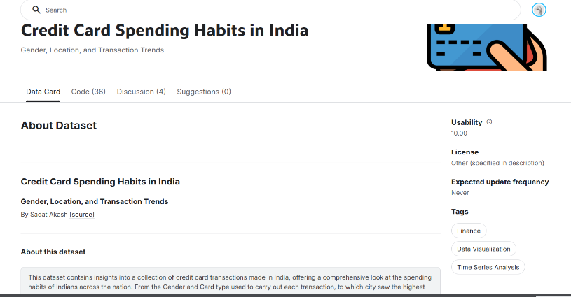
- Tools & Methodology
- Tableau Help: Clean and Shape Data in Tableau Prep.​
- Tableau Public Dashboards: Credit Card Transaction Examples.​
- Research Papers & Articles
- A Credit Card Usage Behaviour Analysis Framework. SCITEPRESS.​
- Surge in Credit Card Spends: Key Drivers. IBEF Blog.​
- Behavioral Analysis of Credit Card Users in a Developing Country. CCSENET.​
- GitHub Repositories
- CreditCardSpendingHabitsInIndia by lijesh010.​
- BankCard-Analytics by ninadpatil09.

